**Lab 5**



**Circuits and System 1 lab**

Submitted by: **Maaz Habib**

Registration No. :**20PWCSE1952**

Class Section: **C**

“On my honor, as student of University of Engineering and Technology, I have neither given nor received unauthorized assistance on this work.”

Submitted to**: Engr Faiz ullah**

Month Day, Year (May 24, 2021)

Department of Computer Systems Engineering

University of Engineering and Technology, Peshawar

Experiment # 5:

Objective:

* To verify Kirchhoff’s Voltage Law (KVL) on PSPICE and know relationship between varying resistors and applied voltage.

Apparatus:

1. PSPICE

### Kirchhoff’s Voltage Law (KVL):

Kirchhoff’s Voltage Law states that:

“**The algebraic sum of voltages in a closed path is equal to zero that is the sum of source voltages is equal to the sum of voltage drops in a circuit”.**

If the current flows from higher potential to lower in an element, then we consider it as a voltage drop and If the current flows from lower potential to higher potential, then we consider it as a voltage rise.

Thus, the energy dissipated by the current must be equal to the energy given by the power supply in an electric circuit.

[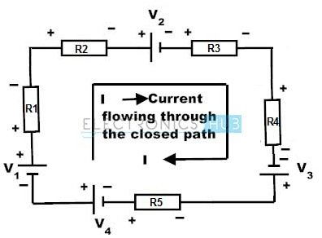](https://www.electronicshub.org/wp-content/uploads/2015/03/image.jpg)

Consider above circuit where the direction of current flow is taken clockwise. Various voltage drops in the above circuit are V1 is positive, IR1is negative (drop in voltage), IR2 is negative (drop in voltage), V2 is negative, IR3 is negative (drop in voltage), IR4 is negative (drop in voltage), V3 is positive, IR5 is negative and V4 is negative. By applying KVL, we get

V1 + (-IR1) + (-IR2) + (-V2) + (-IR3) + (-IR4) + V3 + (-IR5) + (-V4) = 0

V1 – IR1 – IR2 – V2 – IR3 – IR4 + V3 – IR5 – V4 = 0

V1 – V2 + V3 – V4 = IR1+ IR2 +IR3 + IR4 + IR5

Hence the KVL is also known as “**the law of conservation of electrical energy”** because the sum of voltage drops is equal to the sum of voltage sources in a closed path.

## **What is PSpice Simulation?**

PSpice is Cadence’s electronic [circuit simulation tool](https://www.orcad.com/products/orcad-pspice-designer/overview). It typically takes a netlist generated from OrCAD Capture, but can also be operated from MATLAB/Simulink. PSpice lets you simulate and analyze your analog and mixed-signal circuits within OrCAD. PSpice calculates complex node voltages and branch currents at each frequency across your design and generate waveform plots for further analysis.

**With PSpice, you can perform**:

* DC Sweep: Change component value and graph the results.
* AC Sweep: Analyze the frequency response of a circuit.
* Transient Analysis: Set a time period and analyze the response of your circuit.

**Some of the more advanced simulations you can use with PSpice Designer Plus which include:**

* Monte Carlo analysis on multiple components varied across their tolerance ranges to help predict your production yield under different conditions. This can be used to identify which parts can have their tolerances widened, reducing cost without sacrificing performance.
* Smoke Identify increases in junction temperature, secondary break-downs, power dissipation stresses, and current violations throughout your design.
* Optimizer Automatically optimize analog circuits and systems to find the best component values for your performance goals and constraints.
* Parametric Plotter sweep multiple design and model parameters at once in plot or tabular form.

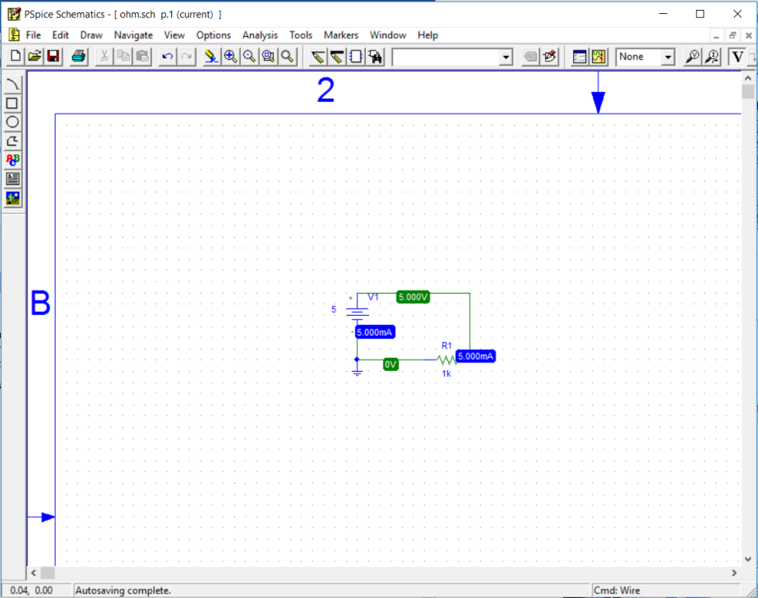

**Procedure:**

1. Open schematic program of **PSpice**.
2. Click on the **Get New Part** button on the toolbar.
3. In the search bar type **r** and place two the resistors on the white sheet.
4. Then type **vdc** in the search bar and place it on the white sheet.
5. Then type **gnd-earth** and place on the white sheet.
6. Now arrange these components on the white sheet according to the circuit diagram as following:

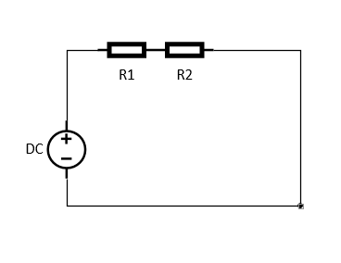

Figure 1: Circuit diagram

1. Click on the simulation button in the toolbar and make sure that the voltage and current biased buttons are pressed so that you can take readings of the circuit.
2. **For 5V:**

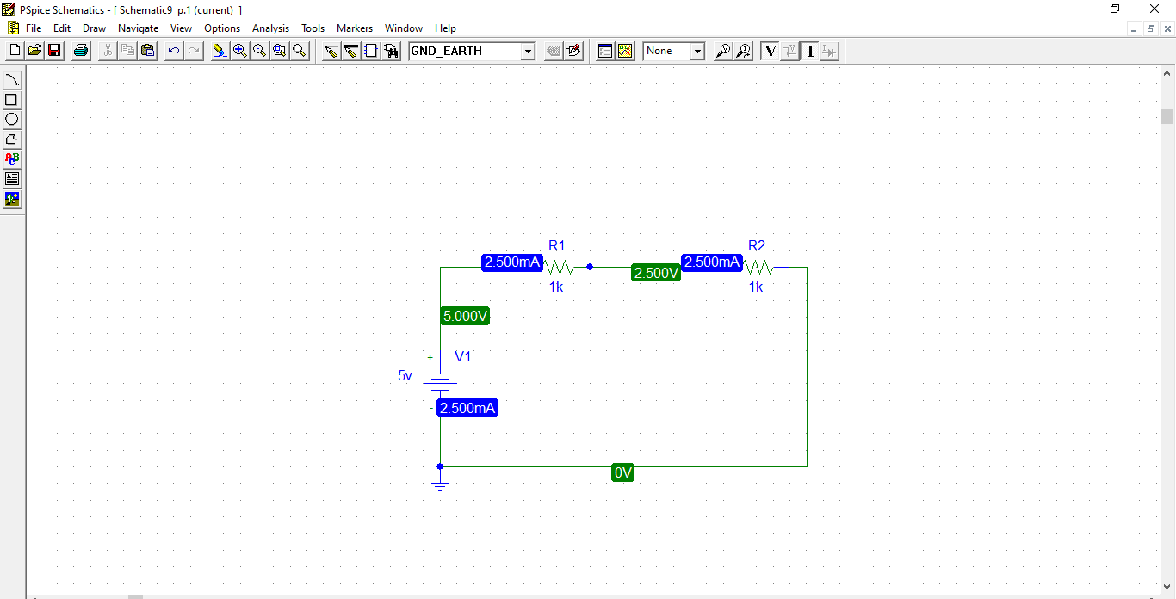

1. **For 10V:**

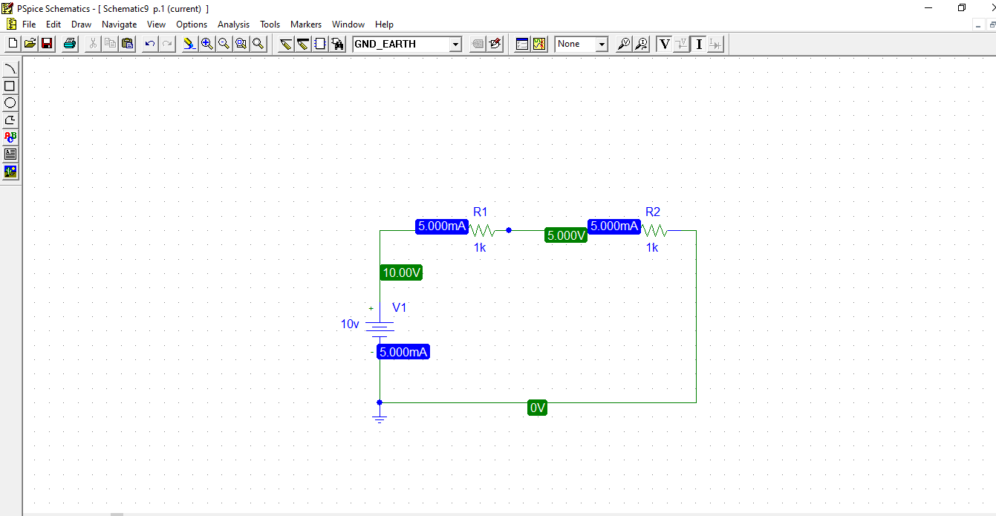

1. **For 15V:**

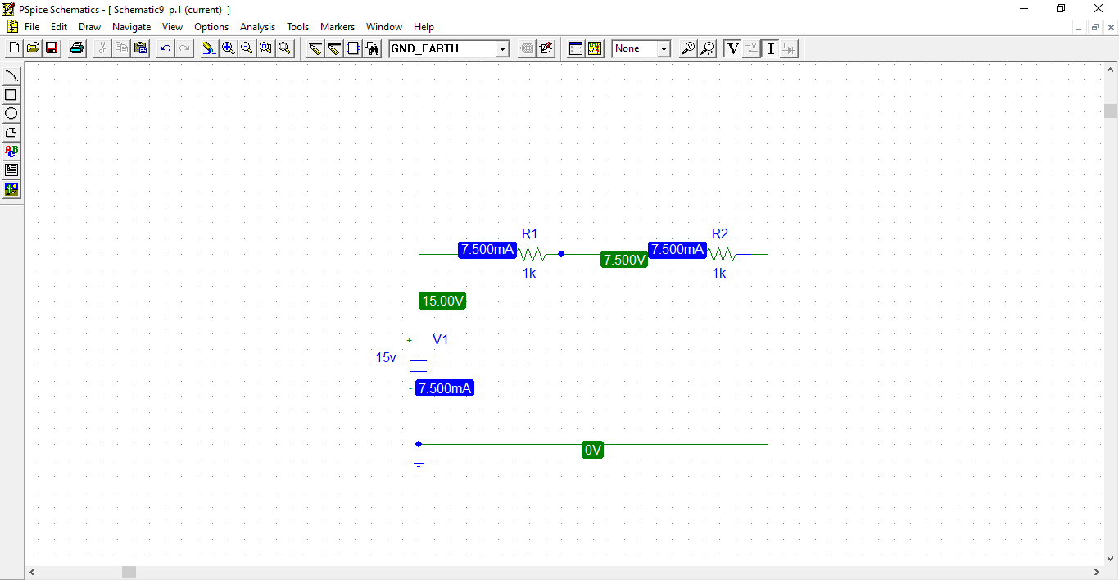

1. **For 20V:**

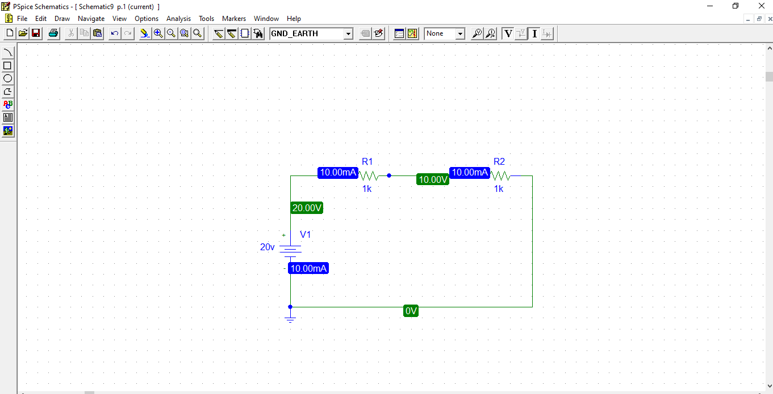

1. **For 30V:**

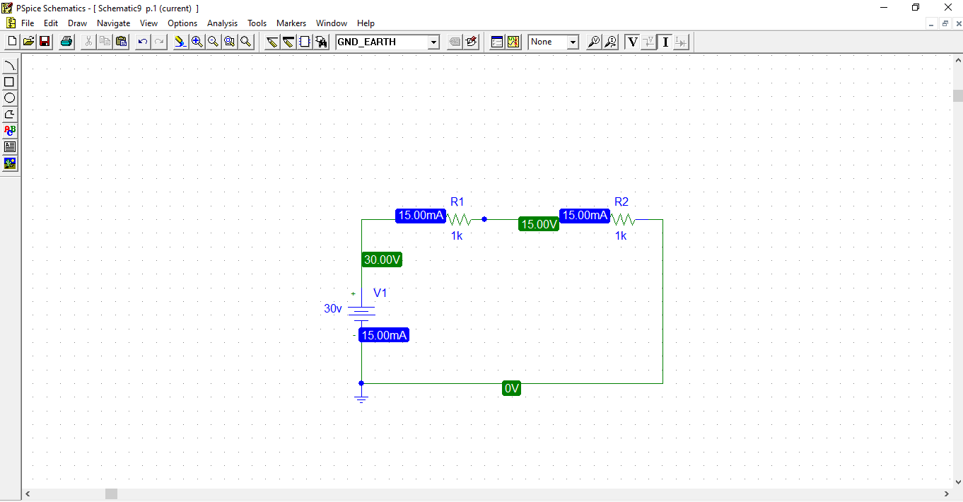

**Observation:**

|  |  |  |  |  |  |  |  |  |
| --- | --- | --- | --- | --- | --- | --- | --- | --- |
| **S.no** | **Vs**  **(actual)**  **(V)** | **R1**  **(Measured)**  **(Ω)** | **R2**  **(Measured)**  **(Ω)** | **V1**  **(Measured)**  **(V)** | **V2**  **(Measured)**  **(V)** | **V1+V2**  **(V)** | **Error** | **Percentage**  **Error**  **(%)** |
| 1. | 5 | 1K | 1K | 5.000V | 2.500V | 7.5 V |  |  |
| 2. | 10 | 1K | 1K | 10.00V | 5.000V | 15V |  |  |
| 3. | 15 | 1K | 1K | 15.00V | 7.500V | 22.5V |  |  |
| 4. | 20 | 1K | 1K | 20.00V | 10.00V | 30V |  |  |
| 5. | 30 | 1K | 1K | 30.00V | 15.00V | 45V |  |  |